Techno - Commercial Offer -

Technical Specification for Product

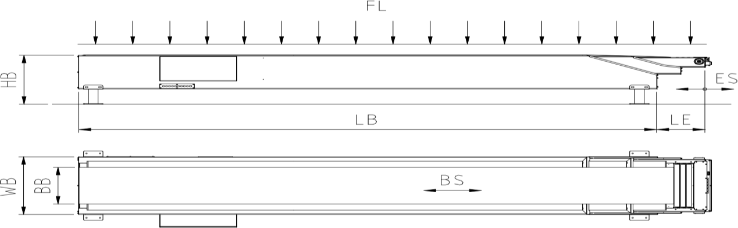

Sr. No. | PARTICULARS | Specifications
1 | Base Section Length (LB) | 5500mm
2 | Telescopic Length (LE) | 3000+3000+3000 mm
3 | Total Extended Length (LB+LE) | 5500+9000=14500mm
4 | Working Height (HB) | 850 mm
5 | Belt Width (BB) | 650 mm
6 | Belt Type | 2 Ply 3.2 mm PVC
7 | Belt Speed | 15-30mtr/min
8 | Belt Direction | Loading/Unloading
9 | Belt Load Max. (FL) | 50 kg/mtr
10 | Belt Drive | 3 HP [ With Bonfiglioli Gearbox]
11 | Telescoping Speed | 8-10 Mtr/min
12 | Telescopic Drive | 2HP [ With Bonfiglioli Gearbox]
13 | Main Voltage | 415Volt 50Hz 3-Phase

14 | Control Voltage | 24 Volt DC
16 | ELECTRIC MOTOR | CG/BBL , IE2
17 | Height adjustable with hydraulic arrangement | Yes Tank capacity 12 ltr
18 | Movable | Yes
19 | Safety Sensors | Included
20 | Inclination Considered from / to Ground floor | Yes

21 | Guide Should provide at Fixed conveyor so that Boxes goes in line.
22 | Sensor Should provide at conveyor for number of Box count.
23 | PLC with HMI provided for Integration purpose with provision of Ethernet Network system.
24 | Spot Light is provided at End of Conveyor.
25 | Wheel is provided for Movement of conveyor.

- Electricals
Sr.  No. | COMPONENTS | MAKE
1 | Electric Motor | Bonfiglioli
2 | Contactor/Over Load Relays/VFD | Siemens
3 | MCB/MPCB/Indicators | Siemens
4 | Panel Box Enclosure | DL TECH
5 | Push Buttons/Limit Switches | Teknik
6 | Fittings | Standard
7 | Cables | Polycab/Avanti
8 | Connectors | Phoenix/Connectwell/Elemek

- Hydraulics
Sr.  No. | COMPONENTS | MAKE
1 | Power Pack | Target innovation
2 | Hydraulic Cylinders | DL TECH
3 | Hydraulic hose pipe | Parker
4 | Hydraulic Oil | Servo VG 68

- Others
Sr.  No. | COMPONENTS | MAKE
1 | Gear Box | Bonfiglioli
2 | Belt | PVC
3 | Bearing & Bearing Units | SKF
4 | Return Roller | DL TECH Make
5 | Drive & Driven Roller | DL TECH Make
6 | Chain & Sprockets | TI Diamond
7 | MOC | Mild Steel Jindal/Apollo
8 | Surface Treatment | Powder Coated

Commercial Offer -

Sr. | Description | Qty  (Unit ) | Price in INR/  Unit | Price in INR/ Unit
1 | Basic cost of Telescopic conveyor – (5.5mtr , 3+3+3, width 650mm without counting system) | 1 | 1400000/- | 1400000/-  + Taxes extra
2 | Basic cost of Telescopic conveyor – (5.5mtr , 3+3+3, width 650mm counting system) | 1 | 1560000/- | 1560000/- +Taxes extra.

